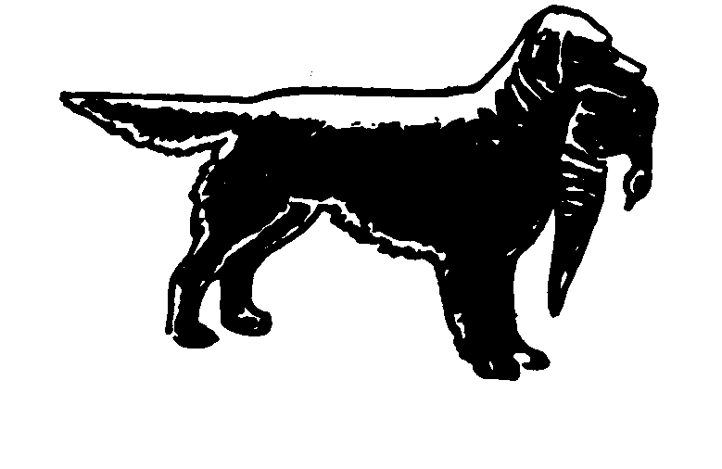
Northern Golden Retriever Association
Est. 1946

Treasurer  Mr John Newsham  61 Churchill Meadow  Ledbury, Herefordshire  HR8 2DQ  01531 825975 | Chairman:  Mr Steven Crookes | President :  Mr Tony Hickinbottom
Show Secretary  Miss Angela Aulton  Littleworth House Farm  Alkmonton  Ashbourne  Derbyshire. DE6 3DG  01335 330660 | Field Trial Secretary  Mr Philip Wagland  33 Almond Grove  Worksop S80 1AU  01909 476024 | General Secretary  Mr Philip Smithies  52 Hollin Lane  Middleton  Manchester. M24 5EE  0161 653 3050

Dear Prospective Member,

Thank you for your enquiry about the Northern Golden Retriever Association, which was founded in 1946. The association runs field trials and shows, also through the Pennine training area runs gundog working tests and training classes. Currently the NGRA run up to six field trials per year: An open qualifying stake for Golden Retrievers, one all aged stakes for any variety Retrievers, two/three novice stakes for any variety Retrievers and a novice stake for Golden Retrievers.

The Pennine training area organises training sessions and gundog working tests, usually a novice and open test each year, plus matches against other clubs.

The NGRA holds a championship show and an open show for Golden Retrievers each year and has a website www.northerngoldenretriever.org.uk

Annual membership is £10.00 single or £12.00 joint. This is due on 1st January each year and membership will lapse if any outstanding subscription is not renewed by March 1st.
Payment may be made by cheque or standing order. Overseas members may pay by International Bank Transfer. (Details can be obtained from the General Secretary or Treasurer).

Enclosed with application form is a copy of the Association’s code of ethics, all members of the NGRA must agree to abide by the code of ethics as laid down by the Association.

If you wish to join kindly complete the attached form and return to the General Secretary.

Yours sincerely
Philip Smithies
Mr P J Smithies
General Secretary
Northern Golden Retriever Association: Application for membership

Existing members Please do not use for membership renewal
Please use the renewal form sent with the Winter Newsletter

[*Please delete as appropriate]
*I/we wish to join the Northern Golden Retriever Association. *I/we agree to abide by the Rules and Regulations and the code of ethics as laid down by the Association.

Name Membership type: *Single £10
*Joint £12
Address Telephone
Kennel Affix
If e-mail correspondence is preferred please state email address:-

Signature[s]

*I/we enclose a cheque for £ for the first membership payment.

Data Protection: Membership details are held on computer in accordance with the General Data Protection Act (2018). This information is used solely for the mailing of association publications. The only disclosures are: (1) A list of members appears in the annual yearbook, the current edition of which is available only to fully paid up members. (2) A membership list is forwarded to the Kennel Club when requested. (as per Kennel Club regulations).

By signing above I/we give consent for the NGRA to hold on its database my name, postal address, telephone numbers, email address.

- I/we understand that the information held on the NGRA database will be used only by the NGRA for the purposes of keeping me advised of events and activities run by the NGRA.; - and, if so requested, this List will be made available to the KC.
- I/we may apply in writing to the General Secretary to advise me/us what information is held in my/our name(s) and this information must be provided within 40 days of the date of request; -
- that I/we may apply in writing to the General Secretary for my information, or any part of my information, to be deleted from the NGRA database at any time.
- that the NGRA will only hold my/our information for the duration of my/our membership of the Club.
- that I/we will confirm any changes in my contact details (my name, postal address, telephone numbers, email address).

I/we wish to receive the following schedules: [tick as appropriate]

Championship show Open Show Field Trial

Do you wish to pay future subscriptions by bankers order? Yes No

If you do not wish your address to be published in the yearbook please contact the General Secretary.

Please return your completed application form and cheque made payable to:-
“Northern Golden Retriever Association” to the Hon. General Secretary,
Mr P J Smithies, 52 Hollin Lane, Middleton, Manchester, M24 5EE

Membership will not become effective until approved by the Executive Committee but you will be eligible to participate in the Association’s events as a member. Voting rights will be conferred on membership acceptance of which you will be informed.
Membership Renewal subscriptions are due on January 1st. Members elected after October shall be deemed to have paid the membership fee for the ensuing year provided that they do not enter an Association show or field trial or any other event as a member during that period.
NORTHERN GOLDEN RETRIEVER ASSOCIATION
GENERAL CODE OF ETHICS
All members of the Northern Golden Retriever Association undertake to abide by its general Code of Ethics.
Club members:
Will properly house, feed, water and exercise all dogs under their care and arrange for appropriate veterinary attention if and when required.

Will agree without reservation that any veterinary surgeon performing an operation on any of their dogs which alters the natural conformation of the animal, or who carries out a caesarean section on a bitch, may report such operation to the Kennel Club.

Will agree that no healthy puppy will be culled. Puppies which may not conform to the Breed Standard should be placed in suitable homes.

Will abide by all aspects of the Animal Welfare Act.

Will not create demand for, nor supply, puppies that have been docked illegally.

Will agree not to breed from a dog or bitch which could be in any way harmful to the dog or to the breed.

Will not allow any of their dogs to roam at large or to cause a nuisance to neighbours or those carrying out official duties.

Will ensure that their dogs wear properly tagged collars and will be kept leashed or under effective control when away from home.

Will clean up after their dogs in public places or anywhere their dogs are being exhibited.

Will only sell dogs where there is a reasonable expectation of a happy and healthy life and will help with the re-homing of a dog if the initial circumstances change.

Will supply written details of all dietary requirements and give guidance concerning responsible ownership when placing dogs in a new home.

Will ensure that all relevant Kennel Club documents are provided to the new owner when selling or transferring a dog, and will agree, in writing, to forward any relevant documents at the earliest opportunity, if not immediately available.

Will not sell any dog to commercial dog wholesalers, retail pet dealers or directly or indirectly allow dogs to be given as a prize or donation in a competition of any kind. Will not sell by sale or auction Kennel Club registration certificates as stand alone items (not accompanying a dog).

Will not knowingly misrepresent the characteristics of the breed nor falsely advertise dogs nor mislead any person regarding the health or quality of a dog.

To refuse a stud service for bitches that are known to suffer from any known hereditary defects or are under 18 months old.

Not to abuse bitches by over breeding, no Bitch is allowed to have more than four litters, cannot be bred from twice within a 12 month period and cannot be bred from under 18 months old, or if she has already had two litters by caesarean section

To understand that dogs grow old and may well require special care and attention and to know that your Golden is not just a dog but a friend and companion.
Breach of these provisions may result in expulsion from club membership, and/or disciplinary action by the Kennel Club and/or reporting to the relevant authorities for legal action, as appropriate.
KC/GJ January 2011

